

ASSIGNMENT No: 21
TITLE: Demonstration and exploration of JDBC classes and interfaces (DriverManager, Connection, Statement).

Name: Avdhoot Mohite Class: CSE A2
PRN: 25070122056 Batch:25-29

Problem Statement
Demonstration and exploration of JDBC classes and interfaces (DriverManager, Connection, Statement).

Learning Objectives
To understand and use the core JDBC classes for database connectivity.

Theory
The JDBC API consists of several classes and interfaces that facilitate database connectivity. The DriverManager class is responsible for loading the appropriate JDBC driver and establishing a connection with the database using a database URL, username, and password. The Connection interface represents an active session between the Java application and the database server. It provides methods to create SQL statements and manage transactions. The Statement interface executes static SQL queries and updates. These classes work together to establish communication between Java programs and databases. Understanding these core components is essential for developing database applications using Java.

Exercise
- Create a program to connect Java with database and display database connection status.

- import java.sql.*;

- public class assignment21a {
- public static void main(String[] args) {

- String url = "jdbc:mysql://localhost:3306/student_db";
- String user = "root";
- String password = "Avdrocks@0504";

- try {
- Connection con = DriverManager.getConnection(url, user, password);

- System.out.println("Database connected successfully!");

- if (!con.isClosed()) {
- System.out.println("Connection Status: Active");
- } else {
- System.out.println("Connection Status: Inactive");
- }

- con.close();
- System.out.println("Connection closed successfully.");

- } catch (SQLException e) {
- System.out.println("Database connection failed!");
- System.out.println(e.getMessage());
- }
- }
- }

OUTPUT:
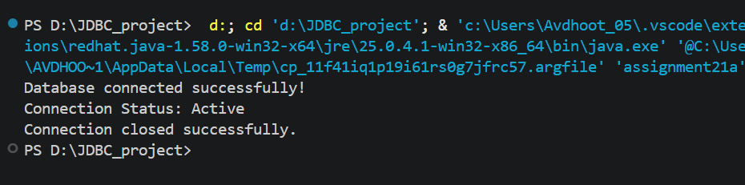

2. Create a Java program to connect with a database and display the connection status. After successful connection, show a message indicating that the Student database is connected successfully.

import java.sql.*;

public class assignment21b {
public static void main(String[] args) {

String url = "jdbc:mysql://localhost:3306/student_db";
String user = "root";
String password = "Avdrocks@0504";

try {
Connection con = DriverManager.getConnection(url, user, password);

if (!con.isClosed()) {
System.out.println("Connection Status: Successful");
System.out.println("Student database is connected successfully.");
}

Statement stmt = con.createStatement();

stmt.execute("SELECT 1");

System.out.println("SQL Statement executed successfully.");

stmt.close();
con.close();

} catch (SQLException e) {
System.out.println("Connection Failed!");
System.out.println(e.getMessage());
}
}
}

OUTPUT:
